# Library Genesis

## What is LibGen

**# Source**: **Windows ScreenShots From Site -> https://welib.org/ at [9/21/2025]**

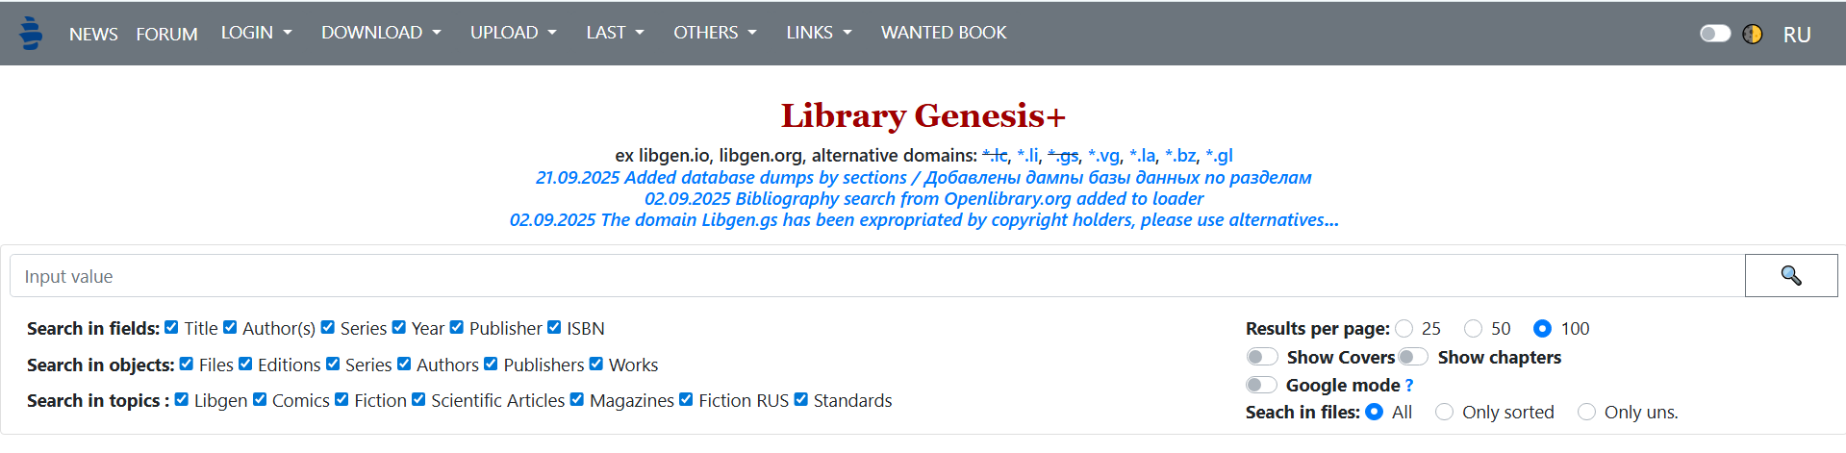

**# Source**: **Chatgpt (GPT-5-Standard) at [9/21/2025]**

* **Library Genesis** (often “LibGen”) is a “shadow library” project that provides free access to a massive quantity of books, academic articles, comics, magazines, etc. ([Wikipedia](https://en.wikipedia.org/wiki/Library_Genesis?utm_source=chatgpt.com))
* It claims access to millions of items: scientific journal articles, academic & general-interest books, etc. ([Wikipedia](https://en.wikipedia.org/wiki/Library_Genesis?utm_source=chatgpt.com))
* It usually works by aggregating content it didn’t originally create — allowing users to search for links to files (“mirrors”) that might otherwise be paywalled or hard to find. ([Wikipedia](https://en.wikipedia.org/wiki/Library_Genesis?utm_source=chatgpt.com))

## How LibGen Operates

**# Source**: **Chatgpt (GPT-5-Standard) at [9/21/2025]**

* Multiple domain names / mirrors exist (because of legal pressure or blocks). Sometimes certain domains are down, but there are often alternatives. ([Library Genesis Guide](https://librarygenesis.net/?utm_source=chatgpt.com))
* Users can search by title, author, ISBN, etc., find a document/book, then download it from one of the mirrored links. ([Wikipedia](https://en.wikipedia.org/wiki/Library_Genesis?utm_source=chatgpt.com))

## Legal & Ethical Issues

**# Source**: **Chatgpt (GPT-5-Standard) at [9/21/2025]**

* Much of the content hosted or linked by LibGen is **copyrighted** — meaning it is not legally free to share in many jurisdictions. ([Wikipedia](https://en.wikipedia.org/wiki/Library_Genesis?utm_source=chatgpt.com))
* Because of this, using LibGen can be **illegal or infringing intellectual property rights** depending on local laws. ([Wikipedia](https://en.wikipedia.org/wiki/Library_Genesis?utm_source=chatgpt.com))
* There have been legal actions against LibGen in some places, and domain seizures or orders to block certain mirrors. ([Wikipedia](https://en.wikipedia.org/wiki/Library_Genesis?utm_source=chatgpt.com))

## Risks for Users

**# Source**: **Chatgpt (GPT-5-Standard) at [9/21/2025]**

* **Legal risk**: Depending on your country’s laws, downloading copyrighted material from LibGen could expose you to potential liability (though enforcement varies).
* **Security risk**: Files from unofficial or mirrored sources may not be safe. They could contain malware, or poor-quality scans, etc.